13.35: a) With the approximations given, 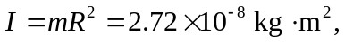
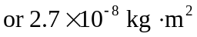 to two figures.
b) .

